**Cabildo, Adan L. | BSCS-SS212**

# What variables might be relevant to the decision?

**What are the hypotheses about how to improve the data? And what variables are needed to test the hypotheses?**

* The frequency of pirate attacks exhibits chronological patterns, such as seasonal variations or trends over the years.
  + Variables required:

1. Date (Year and Month)
2. Attack Type
3. Count of Pirate Attacks

* Certain geographic regions are more prone to pirate attacks.
  + Variables required:

1. Latitude
2. Longitude
3. Nearest Country
4. Location Description

* Specific ship characteristics, such as type, speed, or size, are correlated with a higher likelihood of being targeted in pirate attacks.
  + Variables required:

1. Vessel Type
2. Vessel Status
3. Attack Type

# What data sources can inform those variables?

**What are the possible sources of the necessary information?**

* International Maritime Bureau (**IMB**) which is under the International Chamber of Commerce – Commercial Crime Services (**ICC-CCS**)
  + Link: <https://www.icc-ccs.org/>

**Are there any considerations that constrain which data sources can be used (timeliness, access, privacy, cost, standards, etc.)?**

* Based on terms and conditions that ICC-CCS provides, where the **dataset** from Kaggle came from, the following can be considered:
  + The provided data is for general information and may change without notice.
  + The ICC-CCS cannot guarantee accuracy, completeness, and suitability of the data provided.
  + ICC-CCS provides live data of piracy (but this project’s scope is for the years 1993 to 2020 only).

**What does exploratory data analysis reveal about the available data?**

When inserting Attack Description into tableau, a warning is prompted, proving transforming of data is required for this kind of variable.

Figure . Warning Prompt for inserting Attack Description

This transformation of data is also appropriate for Location Description because it contains a string data type that may be a problem for modelling and analysis.

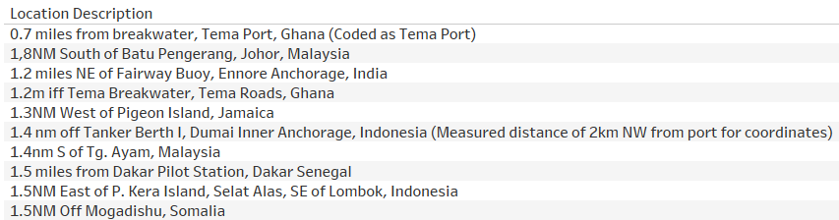

Figure . Displaying 10 values of Location Description

Next, the time must be standardized into military time format.

Figure . Displaying Time value differences

# How will you transform the raw data into variables suitable for modeling?

**What does the profile of each data source reveal about the quality of the available data?**

* After analyzing the data and its source, which came from Kaggle that originates from ICC-CCS, the data follows a standardized format that can be easily used for machine learning and data analytics.
* The sources provide a csv file format for easier and compact dataset sharing.
* ICC-CCS also provides live or up-to-date data that can be used for future project improvement.

**How should data from different sources be integrated? Is there a need to integrate?**

* Integration is not required because this project has only one source which is Kaggle that originates from ICC-CCS. Kaggle uses the specific format from ICC-CCS.
* Should the project evolve into a bigger development, integration will be easier for Kaggle (which is the current source) and ICC-CCS (which the current source originates) uses the same format and contains csv file type.

**What additional preparation steps are necessary on the integrated data to yield variables for analytic modeling?**

* **Attack Description** values can be summarized and clustered by cross matching the values that contain 1 or more similar words, for easier analyzation and modelling.
* **Location Description** values can be summarized and clustered by cross matching the values that contain 1 or more similar words, for easier analyzation and modelling.
* **Not Applicable (NA) Attack Types** will be removed.
* **Time** will be converted to military time format.
* **Eez Country (Exclusive Economic Zone)** will be converted to its full country name.
* In conclusion, data that contains NA or missing values will be removed. Additionally, the values will be converted to standardized format such as, but not limited to, Military format for Time.